**Course: Advanced Bioinformatics**

**Module title: Data Image Mining.**

**Module no. : 136**

**Image Mining**

**Data Mining**

* Use of tools to extract ‘nuggets’ of useful information & patterns in bodies of data for use in decision support and estimation
* Automated extraction of hidden predictive information from (large) databases.

**Data Pyramid**

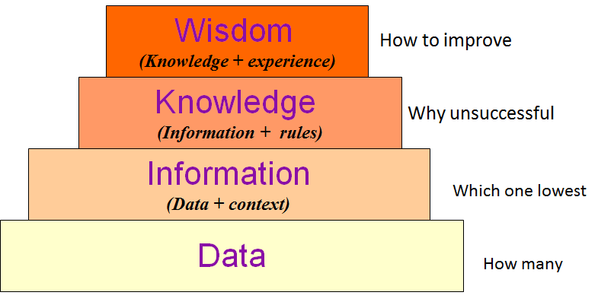

**Image Mining**

* Extension of data mining to image domain.
* Extraction of patterns from large collection of multimedia objects.
* Implicit knowledge, image data relationship or other patterns not explicitly stored in the images.
* Discover image patternsthat are significant in given collection of objects.
* To extract (searching and finding) useful patterns from large number of image data.
* Satellite, medical & digital photographs in www or any repository.

